**Using services & dependency injection**

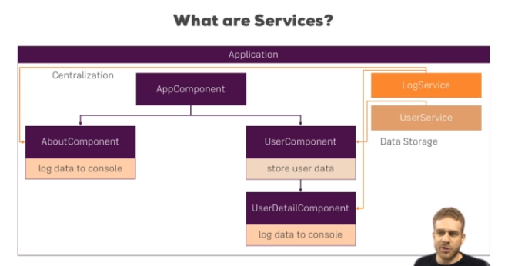

**Creating a Logging Service**

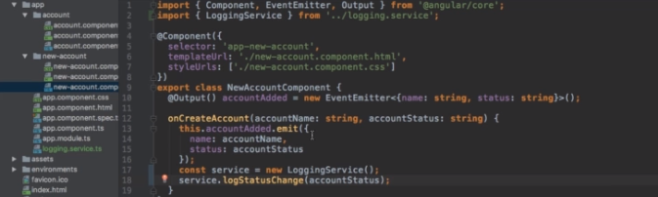

**Injecting the Logging Service into Components**

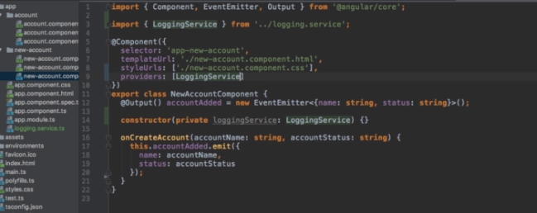

**Creating a Data Service**

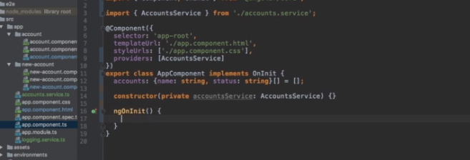

**Understanding the Hierarchical Injector**

